

Software Engineering Department
Braude College of Engineering
Final Project – Phase A (61998)

Sen2Pro
A Probabilistic Perspective to Sentence Embedding
from Pre-trained Language Model
26-1-R-21

Nikita Konovalenko 321237406
Kfir Cohen 316112176

Advisors:
Dr. Renata Avros & Prof. Zeev Volkovich

Link to GitHub:
https://github.com/KfirCohen-PyLab/Final_Degree_Project_Phase_A

Chapter 1: INTRUDOCTION
This project builds upon the foundational work of Sen2Pro, a recent method for constructing probabilistic sentence embeddings. Unlike traditional sentence embedding approaches, which represent text as a single deterministic point in a vector space, Sen2Pro models each sentence as a Gaussian distribution, thereby capturing both its semantic representation and the uncertainty associated with it. This probabilistic formulation provides a richer and more flexible representation of language, particularly suited for tasks where ambiguity and variability play a central role. The present work extends this framework and adapts it to the task of authorship recognition.
Authorship recognition concerns the identification of an author based on stylistic and linguistic characteristics present in a text. This problem is relevant in domains such as forensic linguistics, literary analysis, and digital security, where determining or verifying authorship is essential for resolving disputes, detecting plagiarism, or identifying impersonation. The task is challenging due to the subtle nature of writing style, which may be influenced by genre, historical period, collaboration, or intentional disguise. In addition, an individual author’s style may evolve over time or vary across contexts, making reliable identification difficult when relying on surface-level textual features alone.
A classical and widely studied application of authorship recognition is the Shakespeare authorship question, which examines whether William Shakespeare was the sole author of the works attributed to him. This debate combines historical uncertainty with linguistic complexity and has therefore become a benchmark problem for computational authorship analysis. It provides a compelling test case in which advanced modeling techniques can uncover stylistic patterns that are not readily observable through manual inspection. As such, it serves as an appropriate motivating example for evaluating probabilistic approaches to sentence representation and stylistic analysis. version removes all first-person pronouns and reformulates claims using passive voice and neutral scientific phrasing, while preserving technical content, structure, equations, and references exactly as in the original file.

Our research builds upon the foundational work of Sen2Pro, a recent method for creating probabilistic sentence embeddings. Unlike traditional sentence embeddings, which represent text as a single point in vector space, Sen2Pro models each sentence as a Gaussian distribution, capturing both its semantic meaning and the uncertainty associated with its representation. Our project extends and continues this line of research, applying and adapting its probabilistic framework to the complex task of authorship recognition.
Authorship recognition is the task of identifying who wrote a given text based on its stylistic and linguistic features. It matters in fields like forensics, literary studies, and digital security, where verifying or uncovering an author’s identity is essential - whether to resolve historical mysteries, identify plagiarism, or detect digital impersonation. The main challenges arise because writing style can be subtle, influenced by genre, time period, collaboration, and intentional imitation. Furthermore, an author's style can change over time, vary by genre, or be deliberately disguised, and many standard methods struggle to capture the subtle, fluctuating nuances of short text patterns. This makes it difficult to distinguish between authors using simple rules or surface-level features with high confidence.
Authorship recognition is famously applied to the Shakespeare authorship question - the long-standing debate over whether William Shakespeare truly wrote all the works attributed to him. This case is particularly relevant because it combines historical mystery with linguistic complexity, attracting both scholarly and public interest. It serves as a classic testbed for authorship methods, where advanced computational techniques can analyze stylistic patterns invisible to the naked eye.

Chapter 2: Algorithms and Mathematical Foundations
This chapter establishes the theoretical and algorithmic foundations of the proposed framework. It presents the mathematical basis for probabilistic sentence representations, reviews the Transformer architecture, and describes the integration of modern pre-trained language models into the Sen2Pro framework. Particular emphasis is placed on the extension of this framework to authorship recognition, incorporating uncertainty modeling, diagonal covariance approximation, and controlled textual perturbation.
This chapter establishes the theoretical and algorithmic foundation of our work. We present the mathematical basis for probabilistic sentence representations, review the Transformer architecture, and detail how modern language models are integrated into the Sen2Pro framework. Crucially, we explain how this framework is extended for authorship recognition, incorporating uncertainty modeling, diagonal covariance approximation, and controlled textual perturbation.

2.1 Mathematical Background
2.1.1 From Point to Probabilistic Embeddings
Traditional sentence embedding approaches map a sentence $s$to a single deterministic vector $v∈R^{d}$, implicitly assuming a fixed and unambiguous representation. In practice, natural language is inherently variable: meaning may depend on context, and identical semantic content can be expressed through multiple surface forms. To account for this variability, Sen2Pro represents each sentence as a multivariate Gaussian distribution $N(μ,Σ)$, where $μ∈R^{d}$denotes the mean vector capturing the central semantic tendency, and $Σ∈R^{d×d}$represents the covariance matrix encoding uncertainty and dispersion. This probabilistic formulation enables the explicit modeling of two forms of uncertainty relevant to authorship analysis: model uncertainty arising from stochastic components of the neural network, and data uncertainty induced by paraphrasing and stylistic variation (Lingfeng Shen, 2023).
Traditional sentence embedding methods map a sentence $s$ to a single, deterministic vector $v$ residing in a d-dimensional vector space ($v∈R^{d}$). This assumes a fixed, unambiguous representation. However, language is inherently variable: meaning can be context-dependent, and the same semantic content can be expressed in multiple ways. To model this, Sen2Pro represents a sentence as a multivariate Gaussian distribution $N(μ,Σ)$, where $μ∈R^{d}$ is the mean vector (central semantic tendency) and $Σ∈R^{d×d}$ is the covariance matrix (uncertainty and spread). This formulation allows us to quantify two key types of uncertainty relevant to authorship: model uncertainty (inherent randomness in the neural network) and data uncertainty (variability from paraphrasing or stylistic choice) (Lingfeng Shen, 2023).

2.1.2 Mathematical Intuition for Authorship
In authorship recognition, the mean vector $μ$encodes the dominant stylistic fingerprint of a text, while the covariance matrix $Σ$characterizes the author’s range of stylistic variation. Dimensions exhibiting low variance may correspond to rigid, author-specific habits, whereas higher variance reflects greater stylistic flexibility. This probabilistic perspective enables the analysis of not only the magnitude of stylistic differences between texts, but also their consistency, which is essential for distinguishing between closely related writing styles.
In authorship recognition, the mean $μ$ captures the dominant stylistic "fingerprint," while the covariance $Σ$ models the author's consistent range of variation. A dimension with low variance may indicate a rigid, author-specific habit, while high variance might reflect flexible stylistic elements. This probabilistic view allows us to measure not just how texts differ, but how consistently they differ, which is critical for distinguishing nuanced writers.
2.2 Transformer Architecture and Model Variants
2.2.1 Encoder-Only Transformers and Pooling
The framework relies on encoder-only Transformer models, which employ the self-attention mechanism to generate contextualized token representations. Self-attention enables each token in a sequence to attend to all other tokens, producing a weighted representation defined as
$$\text{Attention}(Q,K,V)=\text{softmax}(\frac{QK^{⊤}}{\sqrt{d_{k}}})V,$$
where $Q$, $K$, and $V$denote the query, key, and value matrices, respectively, and $d_{k}$is the dimensionality of the key vectors. This mechanism facilitates global contextualization without the use of recurrence or convolution. For sentence-level representation, token embeddings are aggregated using pooling strategies such as the [CLS] token representation or mean pooling. In accordance with stability analyses reported in Sen2Pro, first–last layer average pooling is adopted, combining representations from the first and last Transformer layers to obtain robust embeddings suitable for probabilistic estimation.

Our approach relies on encoder-only Transformer models, which use the self-attention mechanism to generate contextualized token representations. Self-attention allows each token in a sequence to attend to all others, computing a weighted representation as:
$\text{Attention}(Q,K,V)=\text{softmax}(\frac{QK^{T}}{\sqrt{d_{k}}})V$.
where $Q$, $K$, and $V$ are the query, key, and value matrices, and $d_{k}$ is the dimension of the keys. This enables global contextualization without recurrence or convolution. For sentence-level embedding, we pool these token vectors. Common strategies include using the [CLS] token output or mean pooling. Following Sen2Pro's findings on stability, we primarily adopt first-last average pooling (averaging outputs from the first and last Transformer layers), which has proven effective for subsequent probabilistic estimation.

2.2.2 Model Variants for Evaluation
The proposed framework is model-agnostic; however, practical considerations motivate the selection of a focused set of models to balance accuracy, computational efficiency, and robustness. BERT-base is employed as a strong and well-established baseline, while RoBERTa-base is included due to its improved pre-training dynamics, which may yield more discriminative stylistic representations. In addition, a Sentence Transformer model pre-trained for semantic similarity is considered as an efficient benchmark for comparison. This selection reflects an inherent trade-off: larger models may capture finer-grained stylistic patterns, but they incur higher computational costs and do not necessarily provide proportional improvements in uncertainty estimation (Lingfeng Shen, 2023; Zeev Volkovich, 2025).
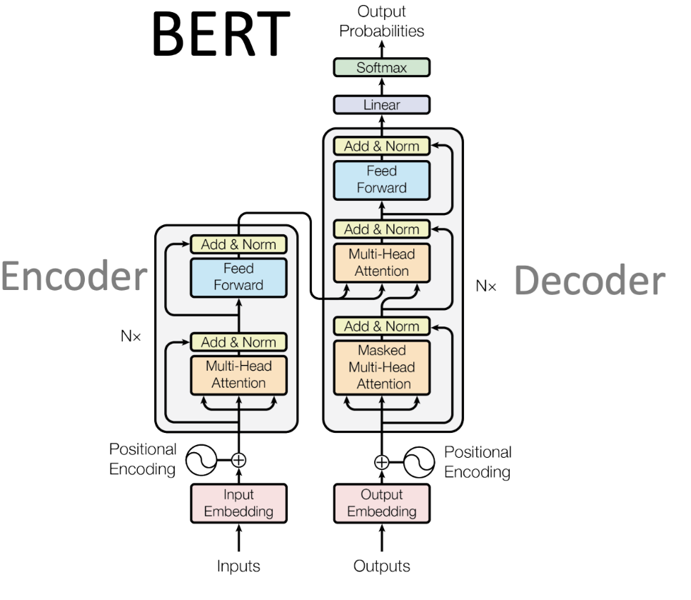
Our framework is model-agnostic, but practical considerations guide our experimental selection. We propose evaluating a focused set to balance accuracy, efficiency, and robustness:
- BERT-base: Serves as a strong, well-understood baseline.
- RoBERTa-base: Offers improved pre-training dynamics, which may yield more discriminative features for style.
- A Sentence Transformer: Pre-trained for semantic similarity, providing an efficient benchmark for comparison. The choice involves a trade-off: larger models may capture finer stylistic patterns but are computationally heavier and may not proportionally improve uncertainty estimation (Lingfeng Shen, 2023) (Zeev Volkovich, 2025).

2.3 The Sen2Pro Algorithmic Framework for Authorship
2.3.1 Sampling for Uncertainty Estimation
The parameters of the Gaussian embedding $N(μ,Σ)$ are estimated through a sampling-based procedure that captures both model and data uncertainty. Model uncertainty is obtained using Monte Carlo dropout, in which dropout layers remain active during inference and the same sentence $s$is passed through the encoder $N$times, yielding a set of stochastic embeddings $\{x_{1},…,x_{N}\}$ that reflect the model’s internal variability. Data uncertainty is captured through controlled textual augmentation, where perturbations are applied to $s$to generate paraphrased variants $\{s_{1},…,s_{N}\}$, whose embeddings reflect inherent variability in sentence representation (Lingfeng Shen, 2023).
We estimate the parameters of the Gaussian embedding $N(μ,Σ)$ via sampling:
- Model Uncertainty: Enabled by Monte Carlo Dropout, where dropout layers remain active during inference. Passing the same sentence $s$ through the model $N$ times yields a set of embeddings $\{x_{1},...,x_{N}\}$, capturing the model's internal variability.
- Data Uncertainty: Generated via controlled text augmentation. Applying textual edits (perturbations) to $s$ creates paraphrases $\{s_{1},...,s_{N}\}$, whose embeddings reflect the sentence's inherent representational variability (Lingfeng Shen, 2023).

2.3.2 Parameter Estimation and Diagonal Covariance
Given a sample set $S=\{x_{1},…,x_{N}\}$, the parameters of the Gaussian embedding are estimated as
$$μ=\frac{1}{N}\sum_{i=1}^{N}{x_{i}},Σ=\frac{1}{N}\sum_{i=1}^{N}{(x_{i}-μ)(x_{i}-μ)^{⊤}}.$$
For high-dimensional embedding spaces, estimation of the full covariance matrix $Σ$ is both statistically unstable and computationally expensive. Consequently, following the Sen2Pro formulation, a diagonal covariance approximation is adopted, denoted by $\hat{Σ}=Diag(Σ)$. This approximation assumes independence between embedding dimensions, trading the ability to model inter-feature correlations for substantial gains in numerical stability, computational efficiency, and tractability of distance computations (Lingfeng Shen, 2023; GPT, 2025).

Given a sample set $S=\{x_{1},...,x_{N}\}$, we calculate:
$$μ=\frac{1}{N}\sum_{i=1}^{N}{x_{i}, Σ}=\frac{1}{N}\sum_{i=1}^{N}{(x_{i}-μ)(x_{i}-μ)^{⊤}}.$$
For high-dimensional embeddings, estimating the full covariance matrix $Σ$ is statistically and computationally prohibitive. Therefore, following Sen2Pro, we use a diagonal covariance approximation, $\hat{Σ}=\text{Diag}(Σ)$. This assumes dimensions are independent, trading off the ability to model feature correlations for immense gains in numerical stability, efficiency, and ease of distance computation (Lingfeng Shen, 2023) (GPT, 2025).

2.4 Integration with the Deep Impostors Method
The primary extension introduced in this work consists of integrating Sen2Pro’s probabilistic sentence embeddings into the deep impostors authorship verification framework (Zeev Volkovich, 2025). During the impostor training stage, a classifier is trained to distinguish between text segments authored by a pair of known impostor authors, where each segment is represented as a Gaussian distribution $N(μ,Σ)$. In the target analysis stage, the questioned text is segmented and encoded into probabilistic representations, which are then processed by the trained classifier to produce a sequence of soft stylistic assignments. Finally, this sequence is transformed into a stylistic signal, and anomaly detection is applied relative to the impostor baseline to yield an authorship verification decision. The use of Gaussian embeddings enriches this signal by explicitly modeling stylistic variability and uncertainty, thereby increasing robustness to natural variation in writing style.
Our core extension involves feeding Sen2Pro's probabilistic embeddings into the deep impostors authorship verification pipeline (Zeev Volkovich, 2025). The process is as follows:
- Impostor Training: For a pair of known "impostor" authors, we train a classifier to distinguish their text segments, which are represented as Gaussian distributions $N(μ,Σ)$.
- Target Analysis: The questioned text is segmented and encoded into Gaussians. The trained classifier processes these, generating a sequence of soft assignments.
- Decision: This sequence is converted into a stylistic "signal". Anomaly detection on this signal, compared to the impostor baseline, yields a verification decision. The use of Gaussian embeddings makes this stylistic signal richer and more robust to variation.

2.5 Noise Injection and Text Perturbation Strategies
To operationalize the data uncertainty component of the Sen2Pro framework and enhance model robustness, controlled noise injection is applied during training. This approach is inspired by Sen2Pro’s use of data augmentation to estimate variability in sentence representations. The textual perturbation strategies considered include lexical substitution, in which words are randomly replaced with context-aware synonyms; random deletion, involving the omission of a small proportion of non-essential words; and local swapping, where two adjacent words are exchanged within a limited window. These perturbations are designed to preserve core semantic content while modifying surface form, thereby simulating natural paraphrastic variation in writing. When integrated into the extended pipeline—where probabilistic Sen2Pro embeddings are provided as input to the deep impostors verification method (Zeev Volkovich, 2025)—this noise injection promotes a more robust authorship model that is less dependent on brittle token-level features and more sensitive to stable stylistic patterns.
To operationalize the data uncertainty component of the Sen2Pro framework and enhance model robustness, we implement controlled noise injection during training. This approach is directly inspired by Sen2Pro's use of data augmentation to estimate the variability in sentence representation. Our planned textual perturbation strategies include:
- Lexical Substitution: Randomly replacing words with context-aware synonyms.
- Random Deletion: Omitting a small percentage of non-essential words.
- Local Swapping: Randomly swapping two adjacent words within a short window.
These perturbations are designed to preserve core semantic content while altering surface form, thereby simulating the natural paraphrastic variation an author might employ. When integrated into our extended pipeline, where Sen2Pro's probabilistic embeddings feed into the deep impostors verification method (Zeev Volkovich, 2025), this noise injection aims to produce a more robust authorship model that is less reliant on brittle, token-level features and more sensitive to genuine stylistic patterns.

2.5.1 Content-Word Masking for Topic-Invariant Style Analysis
Content-word masking is employed as a targeted perturbation strategy in which content-bearing words are replaced with placeholders while function words, syntactic structure, and sentence order are preserved. This transformation effectively removes topical information while maintaining the stylistic and rhetorical skeleton of the text. Such a perturbation is particularly appropriate for authorship recognition, where robustness to topic variation is required. Within the Sen2Pro framework, content-word masking contributes to data uncertainty estimation by enlarging the embedding cloud used for Gaussian parameter estimation. Consequently, stylistically stable dimensions remain concentrated in the mean vector, whereas flexible stylistic variations are reflected in the diagonal covariance. This strategy enables the evaluation of whether stylistic classification remains invariant under topic-destructive transformations, as illustrated in the Sen2Pro pipeline diagram (Figure X).
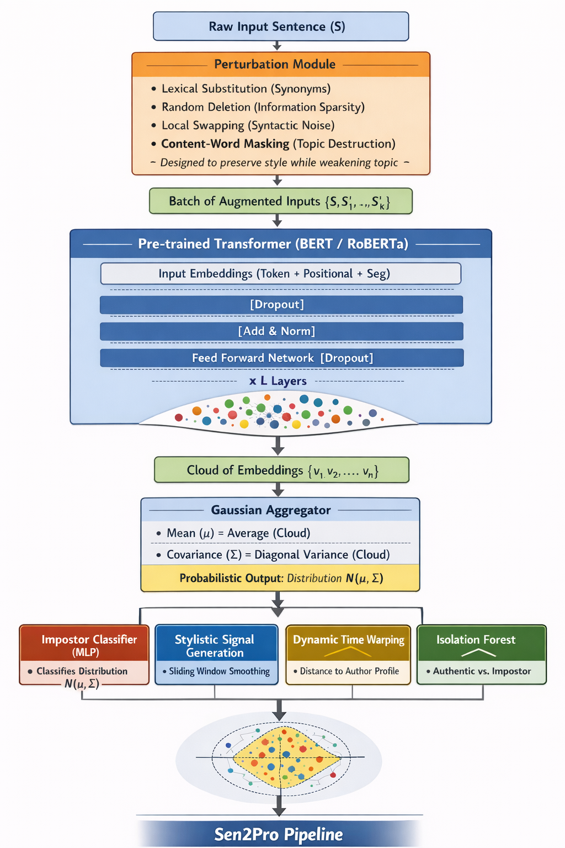
We incorporate content-word masking as a targeted perturbation strategy that replaces content-bearing words with placeholders while preserving function words, syntax, and sentence structure. This transformation effectively destroys topical information while maintaining the stylistic and rhetorical skeleton of the text. Such a perturbation is particularly suited for authorship recognition, where robustness to topic variation is essential. Within the Sen2Pro framework, content-word masking contributes to data uncertainty estimation by expanding the embedding cloud used for Gaussian parameter estimation. As a result, stylistically stable dimensions remain concentrated in the mean vector, while flexible stylistic variations are reflected in the diagonal covariance. This strategy allows us to evaluate whether stylistic classification remains invariant under topic-destructive transformations, as illustrated in the Sen2Pro pipeline diagram (Figure X).

Chapter 3: Probabilistic Sentence Representations with Noise - Aware Sliding Windows
This chapter presents the methodological core of the proposed framework, extending the deep impostors approach (Volkovich & Avros, 2025) through two key innovations. First, deterministic sentence embeddings are replaced with probabilistic Gaussian representations (Sen2Pro; Shen et al., 2023), enabling explicit modeling of uncertainty in stylistic expression. Second, the signal extraction process is refined by introducing sliding-window averaging in place of disjoint chunk aggregation, resulting in a smoother and more continuous stylistic signal. Together, these enhancements form a more robust and expressive pipeline for authorship verification.
This chapter presents the methodological core of our work, extending the deep impostors framework (Volkovich & Avros, 2025) with two key innovations. First, we replace deterministic sentence embeddings with probabilistic Gaussian representations (Sen2Pro; Shen et al., 2023), explicitly modeling uncertainty in stylistic expression. Second, we refine the signal extraction process by introducing sliding-window averaging in place of disjoint chunk aggregation, producing a smoother and more continuous stylistic signal. Together, these enhancements yield a more robust and expressive pipeline for authorship verification.

3.1 Motivation and Scope
In the original deep impostors framework (Zeev Volkovich, 2025), authorship verification relies on deterministic sentence embeddings, where each sentence is mapped to a single fixed vector in a latent space. Although effective, this formulation assumes that sentence representations are precise and unambiguous—an assumption that is frequently violated in real-world text due to paraphrasing, stylistic variation, and contextual ambiguity. To improve the robustness and expressiveness of this framework, probabilistic Gaussian sentence embeddings are introduced (Lingfeng Shen, 2023), modeling each sentence as a distribution rather than a point in embedding space. This formulation enables explicit representation of uncertainty and variability in stylistic expression. In addition, the segmentation and signal-generation process is refined by replacing disjoint chunk averaging with a sliding-window averaging strategy, resulting in a smoother and more continuous stylistic signal. The objective of this chapter is to detail the integration of probabilistic embeddings and sliding-window smoothing into the deep impostors pipeline, thereby yielding a more nuanced and robust model for authorship verification.
In the original deep impostors framework (Zeev Volkovich, 2025), authorship verification relies on deterministic sentence embeddings. Each sentence is mapped to a single fixed vector in a latent space. While effective, this approach assumes that each embedding is precise and unambiguous, an assumption often violated in real-world text due to paraphrasing, stylistic variation, and contextual ambiguity.
To enhance the robustness and expressiveness of this framework, we introduce probabilistic Gaussian sentence embeddings (Lingfeng Shen, 2023). Instead of representing a sentence as a point, we model it as a Gaussian distribution in embedding space. This allows us to explicitly capture uncertainty and variability in stylistic representation. Furthermore, we refine the segmentation and signal-generation process by replacing disjoint chunk averaging with a sliding-window average, producing a smoother and more continuous stylistic signal.
The goal of this chapter is to detail the integration of probabilistic embeddings and sliding-window smoothing into the deep impostors pipeline, thereby creating a more nuanced and robust model for authorship verification.

3.2 From Deterministic to Probabilistic Sentence Embeddings
3.2.1 Deterministic (Original Formulation) and Gaussian Embeddings
In the original framework, a sentence $s$is encoded by a neural encoder $f_{θ}$into a single vector representation,
$$x=f_{θ}(s),x∈R^{d}.$$
This point estimate collapses all semantic and stylistic information—including natural variation and ambiguity—into a fixed representation. Although computationally efficient, such an encoding does not quantify the uncertainty inherent in language representation.

In the original framework, a sentence $s$ is encoded by a neural encoder $f_{θ}$ into a single vector:
$$x=f_{θ}\left(s\right), x∈R^{d}.$$
This point estimate collapses all semantic and stylistic information, including natural variation and ambiguity, into a fixed representation. While efficient, it fails to quantify the uncertainty inherent in language representation.

3.2.2 Gaussian Embeddings (Sen2Pro Formulation)
Following the Sen2Pro formulation, deterministic point embeddings are replaced with probabilistic Gaussian distributions,
$$p(z∣s)=N(μ(s),Σ(s)),$$
where $z∈R^{d}$denotes the probabilistic embedding vector, $μ(s)∈R^{d}$represents the mean vector capturing the central stylistic tendency, and $Σ(s)∈R^{d×d}$is the covariance matrix encoding uncertainty and dispersion in the embedding space.
For computational efficiency and numerical stability, a diagonal covariance approximation is adopted,
$$\hat{Σ}(s)=diag(σ_{1}^{2},…,σ_{d}^{2}),$$
which assumes independence between embedding dimensions while still modeling per-dimension uncertainty.

Following Sen2Pro, we replace point embeddings with Gaussian distributions:
$p\left(z ∣ s\right)=N\left(μ\left(s\right),Σ\left(s\right)\right)$.
where:
- $z∈ R^{d}$ is the probabilistic embedding vector.
- $μ(s)∈R^{d}$ is the mean vector, representing the central stylistic tendency.
- $Σ(s)∈R^{d×d}$ is the covariance matrix, capturing uncertainty and spread in the embedding space.
For computational efficiency and stability, we use a diagonal covariance approximation:
$$\hat{Σ}\left(s\right)=\text{diag}\left(σ_{1}^{2},…,σ_{d}^{2}\right).$$
This assumes independence between embedding dimensions while still modeling per-dimension uncertainty.

3.2.3 Estimating Gaussian Parameters via Monte Carlo Dropout
The parameters $μ$and $\hat{Σ}$are estimated using Monte Carlo dropout (Yarin Gal, 2016). For a given sentence $s$, the encoder $f_{θ}$is applied $N$times with dropout enabled during inference, yielding a set of stochastic embeddings $\{x_{1},…,x_{N}\}$. The parameters are then computed as
$$μ=\frac{1}{N}\sum_{i=1}^{N}{x_{i}},\hat{Σ}=diag (\frac{1}{N}\sum_{i=1}^{N}{(x_{i}-μ)^{2}}).$$
This procedure captures model uncertainty arising from the stochastic nature of the neural network.

We estimate $μ$ and $\hat{Σ}$ using Monte Carlo dropout (Yarin Gal, 2016). For a given sentence $s$, we pass it through the encoder $f_{θ} N$ times with dropout enabled during inference, yielding a set of embeddings:
$\{x_{1},…,x_{N}\}$.
The parameters are then computed as:
$$μ=\frac{1}{N}\sum_{i=1}^{N}{x_{i}},\hat{Σ}=\text{diag}\left(\frac{1}{N}\sum_{i=1}^{N}{(x_{i}-μ)^{2}}\right).$$
This approach captures model uncertainty, the variability arising from the stochastic nature of the neural network.

3.3 Integrating Probabilistic Embeddings into the Deep Impostors Pipeline
The original deep impostors method segments documents into fixed, non-overlapping chunks of sentences or words, with each chunk independently encoded and classified. Such disjoint segmentation may introduce artificial boundaries that disrupt the continuity of stylistic signals. To mitigate this effect, a sliding-window averaging step is applied after classification, smoothing the sequence of stylistic assignments and preserving local continuity.
The original deep impostors method segments documents into fixed, non-overlapping chunks of sentences or words. Each chunk is independently encoded and classified. This disjoint chunking can introduce artificial boundaries that disrupt the natural flow of stylistic signals.
To address this, we introduce a sliding-window averaging step after classification, which smooths the sequence of stylistic assignments and preserves local continuity.
3.3.1 Signal Generation with Sliding Windows
Let a document be segmented into $T$consecutive units. After training a classifier on an impostor pair $(Z_{i},Z_{j})$, each unit $t$is assigned a probability $p_{t}∈[0,1]$indicating its similarity to $Z_{j}$. Instead of averaging probabilities over disjoint chunks, a smoothed stylistic signal $S(⋅)$is computed using a sliding window of size $w$,
$$S(k)=\frac{1}{w}\sum_{t=k}^{k+w-1}{}p_{t},k=1,…,T-w+1.$$
This produces a continuous, real-valued signal that reflects the gradual evolution of stylistic features across the document, reducing noise and boundary artifacts.

Let a document be segmented into $T$ consecutive units. After training a classifier on an impostor pair $(Z_{i},Z_{j})$, each unit $t$ is assigned a probability $p_{t}∈[0,1]$ indicating its similarity to $Z_{j}$.
Instead of averaging these probabilities over disjoint chunks, we compute a smoothed stylistic signal $S(⋅)$ using a sliding window of size $w$:
$$S\left(k\right)=\frac{1}{w}\sum_{t=k}^{k+w-1}{p_{t}} ,k=1,…,T-w+1.$$
This yields a continuous, real-valued signal that reflects the gradual evolution of stylistic features across the document, reducing noise and boundary artifacts.

3.3.2 Advantages of the Sliding-Window Approach
The sliding-window formulation offers several advantages: it produces smoother stylistic signals by reducing high-frequency noise, preserves stylistic continuity through overlapping windows, and improves robustness by diluting the influence of outlier segments or minor perturbations.
- Smoother Signals: Reduces high-frequency noise from local variations.
- Preserved Continuity: Overlapping windows maintain stylistic flow across segment boundaries.
- Robustness: Dilutes the impact of outlier segments or minor perturbations.

3.4 Document-Level Representation and Decision Making
Each document is ultimately represented by a smoothed stylistic signal $S(k)$derived from probabilistic embeddings and sliding-window averaging. Document-level comparison is performed using Dynamic Time Warping (DTW), which accounts for local temporal variations in stylistic expression. The remaining stages of the deep impostors framework remain unchanged: an Isolation Forest algorithm is used to detect anomalous stylistic signals within the target set, and anomaly scores obtained across multiple impostor-pair iterations are aggregated to produce a final authenticity decision. This integrated pipeline—probabilistic embeddings, sliding-window smoothing, DTW-based comparison, and anomaly detection—constitutes the enhanced authorship verification framework.
Each document is now represented by a smoothed stylistic signal $S(k)$ derived from probabilistic embeddings and sliding-window averaging. Documents are compared using Dynamic Time Warping (DTW) on their signals, which accounts for local timing variations in stylistic expression.
The subsequent steps of the deep impostors method remain unchanged:
- An Isolation Forest algorithm detects anomalous signals within the target set.
- Anomaly scores from multiple impostor-pair iterations are clustered to produce a final authenticity decision for each document.
This integrated pipeline: probabilistic embeddings → sliding-window smoothing → DTW comparison → anomaly detection, forms our enhanced authorship verification framework.

3.5 Experiments table for Evaluating the Sen2Pro–Deep Impostors
Test Category | Experiment Description | Purpose | Expected Insight
Perturbation Robustness | Evaluate authorship accuracy under individual and combined perturbations (lexical substitution, deletion, swapping, content-word masking) | Assess robustness to surface-form variation | Verify reliance on stylistic features rather than topic or lexical cues
Topic Invariance Test | Compare performance before and after content-word masking | Measure sensitivity to topical information | Demonstrate topic-invariant stylistic representation
Model Comparison | Compare BERT-base, RoBERTa-base, and Sentence Transformer variants | Analyze model-dependent stylistic sensitivity | Identify trade-offs between accuracy and computational cost
Deterministic vs Probabilistic | Compare deterministic embeddings with Gaussian embeddings | Quantify benefit of uncertainty modeling | Validate probabilistic representations for authorship tasks
Covariance Ablation | Compare diagonal covariance vs fixed variance vs mean-only embeddings | Evaluate contribution of covariance information | Assess importance of uncertainty dimensions
Monte Carlo Sample Size | Vary number of dropout samples (N) | Study stability vs computation trade-off | Determine minimal sampling for reliable estimation
Sliding Window Size | Evaluate different window sizes (w) | Analyze signal smoothness and responsiveness | Optimize stylistic signal continuity
Signal Comparison Metric | Compare DTW with Euclidean and cosine distances | Test sensitivity to temporal misalignment | Justify DTW-based document comparison
Impostor Pool Size | Vary number of impostor author pairs | Measure stability of anomaly detection | Assess robustness of verification decision
Cross-Genre Evaluation | Train and test across different genres | Evaluate generalization ability | Measure stylistic consistency across contexts
Temporal Drift Test | Train on early texts, test on later texts of same author | Assess robustness to stylistic evolution | Evaluate sensitivity to long-term style drift
Noise Sensitivity | Inject increasing levels of perturbation noise | Stress-test model robustness | Identify breaking points of stylistic stability

Table X outlines a set of future experimental evaluations designed to assess robustness, generalization, and uncertainty modeling within the proposed Sen2Pro–Deep Impostors framework.
Bibliography
GPT, C. (2025). Retrieved from chat gpt: https://chatgpt.com/
Lingfeng Shen, H. J. (2023). Sen2Pro: A Probabilistic Perspective to Sentence Embedding.
Yarin Gal, Z. G. (2016). Dropout as a Bayesian Approximation Representing Model Uncertainty in Deep Learning.
Zeev Volkovich, R. A. (2025). Comprehension of the Shakespeare authorship.

